#### Filling missing constituent data

The Swan Canning catchment model produced flow, total nitrogen and total phosphorus as outputs. However, it was not capable of resolving chemical speciation, between, for example, nitrate, ammonium and organic nitrogen, which are variables required for the SCERM boundary inputs. Therefore, the TN and TP in the boundary files were split into their species by using the observed data of species ratios found at those sites. Further, there were other variables that needed to be added to the estuary inflow files, which were not simulated at all in the catchment model, such as dissolved oxygen and salinity. For areas where there was no measured data, the ratios were taken from sites that were adjacent and had similar land use properties (Figure 4).

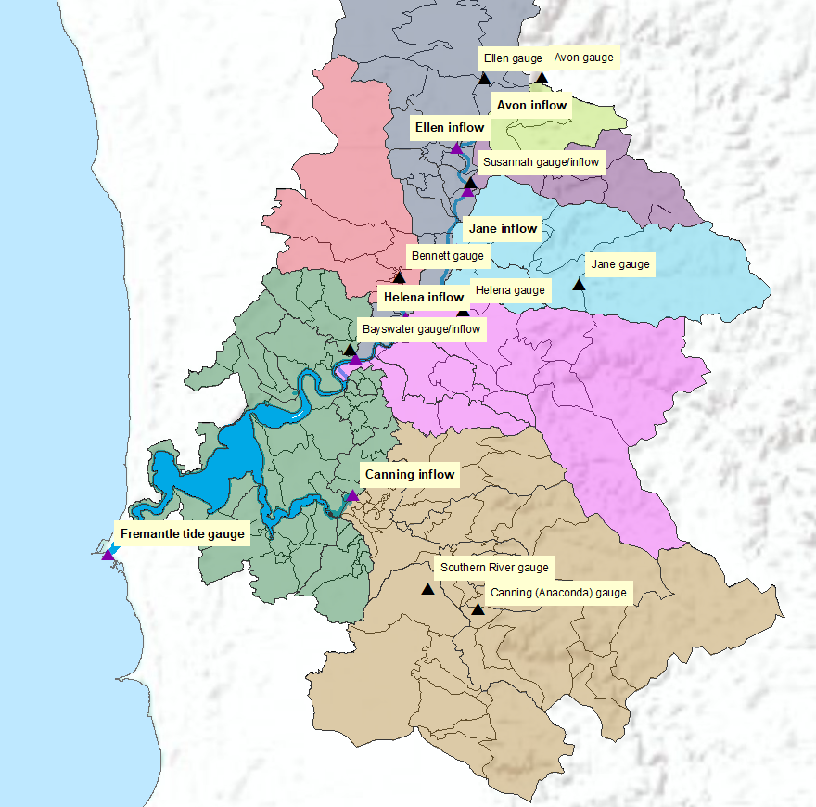

Figure 18 Areas that used the same chemical inflow ratios are shown with the same colour. The Canning gauges have flow only and the water quality data is taken at Kent Street Weir.

For this assessment, the high-resolution model domain is summarised into 12 E